Individual Assignment Report – GlobalAid

# System Vision

## Problem Description

GlobalAid Australia needs to collect donations from donors and provide these donations to programs and projects that support disenfranchised communities all over the world. GAA also wants to implement emerging technologies to provide better services for all stakeholders and to maintain trust, efficiency, and accountability.

## System Capabilities

1. Donors are able to donate online, whether through the website or the mobile app.
2. Donors can choose the program/project that the donation will go to.
   1. Programs/projects are regularly updated online to inform donors and potential donors.
3. Donors can choose to donate anonymously or as registered donors.
   1. If the donor is registered, they will be able to log in and proceed to the payment process. If not, the system will ask for personal and payment details.
   2. Personal details include donor’s title, first name, last name, email, secondary email (optional), password, password confirmation, home phone, mobile phone, preferred contact, and donor’s address.
   3. Payment details include payment type, name on card, card number, expiry date, and card verification value.
4. Donors can choose the donation type.
   1. Donation types are one-off, monthly, and yearly.
5. Donors can specify how much will be donated manually or choose from a set of prespecified amounts.
   1. The prespecified amounts are $10, $20, $50, $100, and $1000.
   2. All credit card payments are powered by Ezidebit and all direct debits are powered by POLi.
   3. The transaction will be sent to the ATO as it is tax deductible (unless the donation is under $2).
6. Donors can choose to give the optional 5% administration fee and 2.5% (variable) merchant fee.
   1. The system will check with the card company to find out its merchant fee.
7. Registered donors can choose to express interest in becoming volunteers, subscribing to email newsletters, and receiving postal mail.
   1. The system will deliver postal mail via Australia Post.

## Business Benefits

* Donors will be allowed to easily donate money to any program and project they wish to donate to. Donors have additional options too, such as offering to volunteer or signing up for GAA’s newsletters.
* GAA will be able to easily collect donations and process taxes and fees for transactions appropriately.
* The implementation of emerging technologies will provide better services for all stakeholders and attract potential donors.

# Stakeholder Analysis

## Identification and Description

* International Federation of Red Cross and Red Crescent (IFRCRC) – The world’s largest humanitarian network with over 13.7 million volunteers, who’s goal is to improve the lives of vulnerable people and improve humanitarian standards all over the world. They provide GAA with regulations and information.
* Steering Committee for Humanitarian Response (SCHR) – A voluntary alliance of CEO’s who represent the world’s leading humanitarian organisations. They also provide GAA with regulations and information, as they were the ones who founded the Code of Conduct for the IFRCRC Movement and NGO’s in Disaster Relief.
* United Nations (UN) – International Organisation that seeks to maintain world peace and prevent wars between nations, established after World War II. Like the IFRCRC and SCHR, they guide GAA with regulations and information with the UN Millennium Development Goals.
* Australian Taxation Office (ATO) – Australian government agency responsible for tax collection. Provides the taxation guidelines GAA must adhere to.
* Donors – Users of the system who donate to GAA.
* Ezidebit – A service used by Australian businesses to collect payments. Used by GAA to process credit card payments.
* POLi – A service also used by Australian businesses to collect payments. Used by GAA to process debit card payments.
* Australia Post – Australian postal service. Will be used by the system to deliver mail to donors.
* Facebook – Social media platform. Will be used by the system to share information publicly.
* Employees – Paid workers of GAA.
* Volunteers – Registered donors who have signed up to volunteer for GAA.
* Executive Officers – GAA’s executive employees; the top of the pyramid. They make the decisions.
* Significant Philanthropists – Well known individuals who donate large sums of money to GAA and hence have partnerships with GAA.
* Partnered Donating Companies – Large companies that donate regularly to GAA and also have partnerships with GAA.
* Bank – Whichever financial institution is managing the funds and financial matters of GAA.
* Credit Card Company – Whichever company the donor uses to make a donation to GAA.
* Email Service – Whichever email service GAA uses to send emails to donors.

## Analysis and Classification

|  |  |  |
| --- | --- | --- |
|  | **Operational** | **Executive** |
| **Internal** | * Employees * Volunteers | * Executive Officers |
| **External** | * Donors * Bank * Australia Post * Card Company * Ezidebit * POLi * ATO * Email Service | * IFRCRC * UN * SCHR * Significant Philanthropists * Partnered Donating Companies |

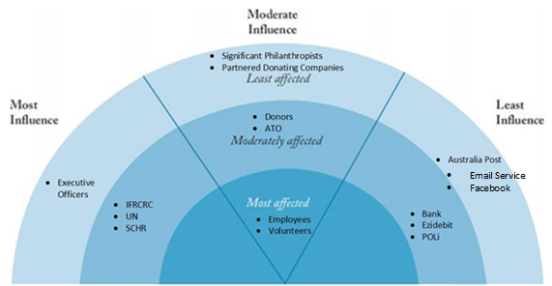

# Rich Picture

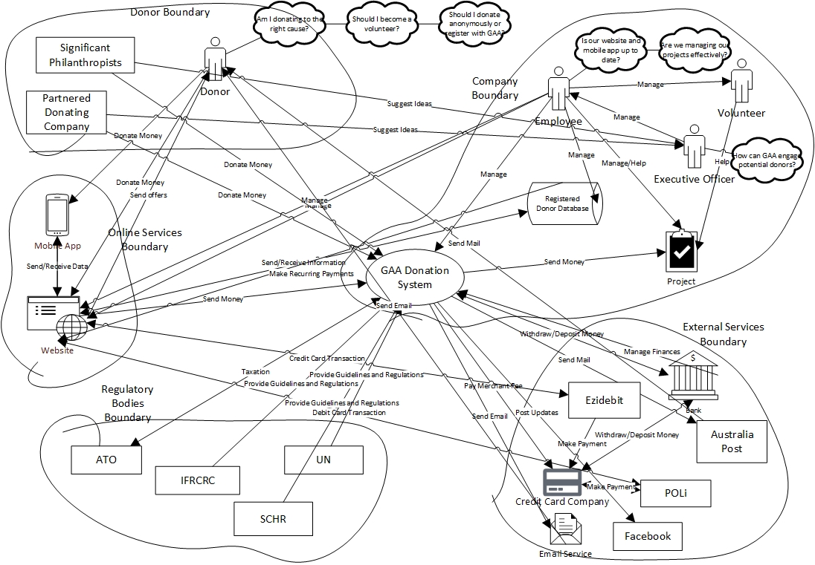

# Event Table

|  |  |  |  |  |  |  |  |
| --- | --- | --- | --- | --- | --- | --- | --- |
| **Event Name** | **Event Type** | **Source** | **Condition** | **Trigger** | **Action** | **Response** | **Destination** |
| Donate Money | External | Donor | Donor wants to donate anonymously. | N/A | Redirect to Payment Form Event. | Payment Form Event | System |
| Donate Money | External | Donor | Donor wants to donate and register. | N/A | Redirect to Person Information Form Event. | Personal Information Form Event. | System |
| Personal Information Form | External | Donor | N/A | Donate Money Event | Donor inputs Donor Title, First Name, Last Name, Email, Secondary Email, Password, Home Phone, Mobile Phone, Preferred Contact, and Donor Address. Redirect to Payment Form Event. | Payment Form Event | System |
| Payment Form | External | Donor | N/A | Personal Information Form Event/Donate Money Event | Donor inputs Payment Type, Name on Card, Card Number, Expiry Date, and Card Verification Value. Redirect to Send to Database Event. | Send to Database Event | ‘’ |
| Send to Database | ‘’ | ‘’ | Donor registered. | Payment Form Event | Send all Personal Information Form and Payment Form values to the registered users database. Redirect to Select $amount Event. | Select $amount Event | ‘’ |
| ‘’ | ‘’ | ‘’ | Donor did not register. | ‘’ | Redirect to Select $amount Event. | ‘’ | ‘’ |
| Select $amount | ‘’ | ‘’ | $10 | Send to Database Event | $amount = $10. Redirect to Perform Transaction Event. | Perform Transaction Event | ‘’ |
| “ | ‘’ | ‘’ | $20 | ‘’ | $amount = $20. Redirect to Perform Transaction Event. | ‘’ | ‘’ |
| “ | ‘’ | ‘’ | $50 | ‘’ | $amount = $50. Redirect to Perform Transaction Event. | ‘’ | ‘’ |
| “ | ‘’ | ‘’ | $100 | ‘’ | $amount = $100. Redirect to Perform Transaction Event. | ‘’ | ‘’ |
| “ | ‘’ | ‘’ | $1000 | ‘’ | $amount = $1000. Redirect to Perform Transaction Event. | ‘’ | ‘’ |
| “ | ‘’ | ‘’ | Custom amount. | ‘’ | Input $amount. Redirect to Perform Transaction Event. | ‘’ | ‘’ |
| Check with Card Company | ‘’ | ‘’ | N/A | Select $amount Event | Find out the merchantFee% and redirect to Pay Optional Fee Event. | Pay Optional Fee Event | ‘’ |
| Pay Optional Fee | ‘’ | ‘’ | Donor has chosen to pay merchant fee and 5% admin fee. | Check with Card Company Event | $amount = $amount + merchantFee% * $amount + 5% * $amount; Redirect to Perform Transaction Event. | Perform Transaction Event | ‘’ |
| ‘’ | ‘’ | ‘’ | Donor has chosen not to pay merchant fee and 5% admit fee. | ‘’ | Redirect to Perform Transaction Event. | ‘’ | ‘’ |
| Perform Transaction | ‘’ | ‘’ | Done with Ezidebit (donor uses credit card). | Pay Optional Fee Event | Redirect to Donation Notification Event. | Donation Notification Event | ‘’ |
| ‘’ | ‘’ | ‘’ | Done with POLi (donor uses debit card). | ‘’ | Redirect to Check with Bank Event. | Check with Bank Event | ‘’ |
| Check with Bank | State | ‘’ | Account Balance >= &amount | Perform Transaction Event | Redirect to Donation Notification Event. | Donation Notification Event | ‘’ |
| ‘’ | ‘’ | ‘’ | Account Balance < $amount | ‘’ | ‘’ | ‘’ | ‘’ |
| Donation Notification | State | System | Donation was successful. | Perform Transaction Event/Check with Bank Event | Email notification of donation to donor, which will include $amount. Redirect to Send Money to Project Event. | Send Money to Project Event | Donor and System |
| ‘’ | ‘’ | ‘’ | Donation was unsuccessful. | Check with Bank Event | Inform donor that their donation was unsuccessful. | N/A | Donor |
| Donate Recurring $amount | Temporal | Donor | Donor has chosen to make automatic monthly donations. | Start of a new month. | Redirect to Donate Amount Event. | Donate Amount Event | System |
| ‘’ | ‘’ | ‘’ | Donor has chosen to make automatic yearly donations. | Start of a new year. | ‘’ | ‘’ | ‘’ |
| Send Money to Project | ‘’ | ‘’ | N/A | Donation Notification Event | $amount is sent to the project specified by the donor. | N/A | Project |

# Context Diagram

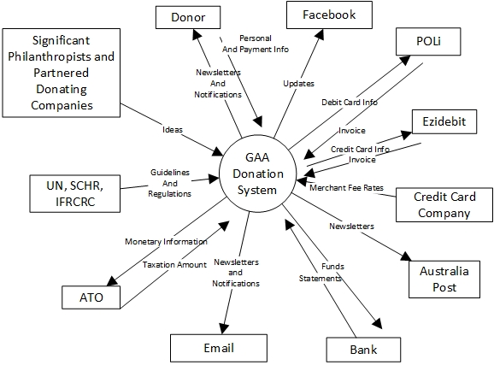

# Assumptions

1. Non-anonymous donors must register.
2. Donation type refers to whether the payment is one-off, monthly, or yearly.
3. Merchant fees vary across card companies. All card companies incur a compulsory merchant fee.
4. Credit cards will not check the donor’s bank balance, as that is not how credit cards work. Debit cards will, however. [Service.nsw.gov.au, 2019]
5. To make recurring payments, the donor has to be registered.
6. Because GAA is a signatory of the Code of Conduct for the IFRCRC Movement and NGO’s in Disaster Relief and they support the UN MDG, this means the IFRCRC and the UN are stakeholders of the GAA donation system.
7. Because the SCHR was the founder of the Code of Conduct for the IFRCRC Movement and NGO’s in Disaster Relief and its members are all signatories to the code, it is included as a stakeholder. [International Federation of Red Cross and Red Crescent Societies, 2019]
8. GAA has significant philanthropists donating to it, as well as partnerships with successful companies which also donate to it.
9. GAA are store their money in a bank and not inside a mattress.
10. GAA will use Facebook to post updates about its programs and projects.
11. Australia Post will be used to deliver mail to donors.
12. The optional fees can only be both given.
13. POLi is an external stakeholder and their notifications are not part of the GAA donation system.
14. This system will only cover online donations.
15. The average donor will be making their donations online, so the assumption is that the average donor can only make their donations online. Partnered donating companies and significant philanthropists have a direct line with the executives of GAA, hence they donate directly rather than through GAA’s website.
16. For a donation to be tax deductible, the donation must be greater than $2. [Etax – 2019 Tax Return Online, 2019]

# References

1. Etax - 2019 Tax Return Online. (2019). How to claim tax deductible donations on your tax return. [online] Available at: <https://www.etax.com.au/claim-tax-deductible-donations/> [Accessed 13 Sep. 2019]
2. International Federation of Red Cross and Red Crescent Societies. (2019). Code of conduct. [online] Available at: <https://media.ifrc.org/ifrc/who-we-are/the-movement/code-of-conduct/> [Accessed 13 Sep. 2019].
3. Service.nsw.gov.au. (2019). Merchant fees | Service NSW. [online] Available at: <https://www.service.nsw.gov.au/merchant-fees> [Accessed 13 Sep. 2019].